Donna Acheson-Juillet
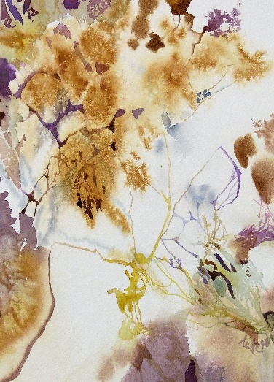
Proposes an exceptional travel log and watercolor workshop

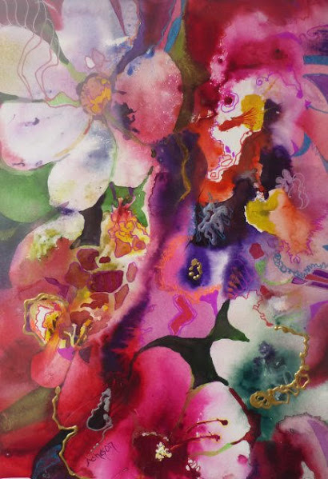
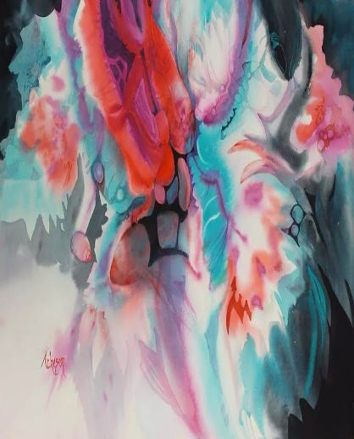

In the South of India,
PONDICHERY and surroundings areas
From 10/01/2021 to 24/01/2021,
15 days of which 12 days will be the workshop (about 60 hours)
This trip will be an opportunity to paint and draw differently, letting us be inspired by India, its atmospheres, its cultural and culinary wealth, its colors and smells, its way of living and its sounds. We will discover another way of thinking and another way to look at life.
Thanks to her approach to drawing, watercolor and composition, Donna will guide us to discover our potential and enhance our skills to refine our own style. This will offer us the opportunity to express our moods, our human values, our feelings.

The Trip:
- Arrival in Chennai on Sunday 10/01/2021 (departure from home on 09/01/2021)
- Workshop :
- From Monday 11/01/2021 to Friday 22/01/2021 (12 days, approximately 60 hours)
- Number of trainees: 10
- Free day on Saturday 23/01/2021
- Departure from Chennai on Sunday 24/01/2021
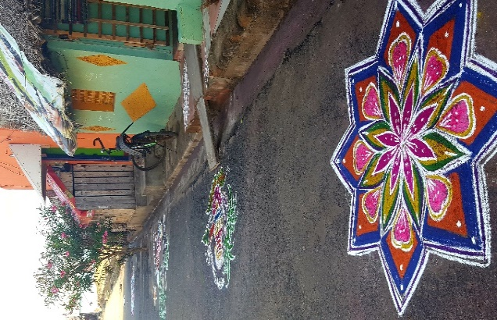
Lodging: Half board hotel (breakfast and dinner included), in a double room
Travel within India: 1) In mini-bus with driver, 2) Airport transfers to hotel roundtrip, 3) Excursions
Costs:
- 600 € for Donna to pay at registration
- 1400 € for: 1) Accommodation, 2) Rental of the mini-bus with driver, 3) Entries on certain sites, 4) Local guide
This price does not include: 1) Return flights and visa, 2) Lunches and drinks, 3) Personal expenses, 4) The extras: Single room supplement, personal insurance, tips
It should be noted that this trip is not organized by a travel agency, but by Françoise, passionate about India and watercolor, and Ashu, Pondicherry, who will be our companion (speaking English and French).
As a plus, Françoise will offer, as part of this internship, meditation sessions and sensory gestures to refine perceptions and release the creative gesture.
When you register, many details about your stay will be provided as well as contact information for Françoise who can answer your various questions.

REGISTRATION FORM
Travel South India, from 10 to 24/01/2021
Family name……………………………………………. First name……………………………
Date of birth ......................................................... Nationality ............................................
Address…………………………………………………………………………………………
……………………………………………………Postal code…………………………………
Email address……………………………………………………………………………………
Fixed phone: .................................................... Tel mobile: .............................................
Estimated technical level (beginner, amateur, confirmed, expert, professional) strike out the useless mentions
Additional information you would like to give us: ............................................................................................................................................. .............................................................................................................................................
...................................................................................................................................................... ...................................................................................................................................
I wish to participate in this travel trip internship - watercolor and acknowledge having read the general conditions of registration:

Date…………………………. at……………………………………….
Signature:

TERMS AND CONDITIONS

Registration & Payment
- To register for this exceptional course, please send your completed registration form and the sum of 600 € by cheque or money transfer to:
Donna Acheson Juillet,
16 Avenue Beauséjour,
78500 Sartrouville, France

It is important to note that the number of participants is limited to 10 people.
Cancellation Policy:
- In case of withdrawal of a participant within 30 days before the start of the trip, the amount already paid will not be refunded.
- In case of cancellation of the trip by the organisers a new date will be proposed to registrants. The trainee already registered but who is not able to participate in this new session will be fully reimbursed sums already paid.
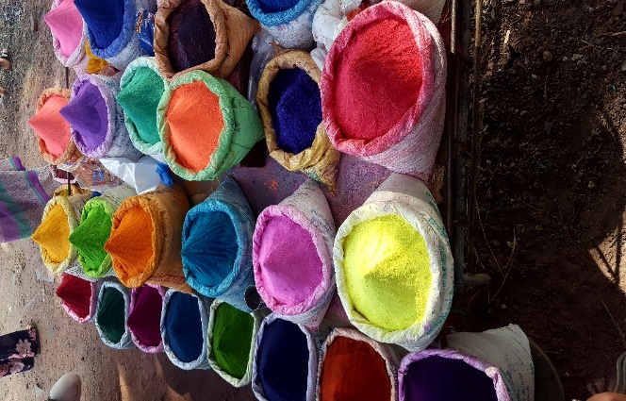
- In case of cancellation of the trip without possibility of proposing another date, all the participants will be fully refunded of sums already paid.

